**Preparation**

Install drivers for Samsung terminals and Nemo Firmware Manager (NFM).

**Important!:** Use only the USB cable that comes with the device. Otherwise, you can spoil the terminal.

**1 Step**

Using the NFM tool, install a special patch.

Turn on the device

- Go to Settings > About phone > tap “Build number” 7 times to enable Developer Options

- Go to Settings > Developer options >

- turn on “Enable OEM unlock”, confirm by pressing **ENABLE**

- turn on “USB debugging”, confirm by pressing **OK**

Connect USB cable to mobile phone. On the phone, you should see this:

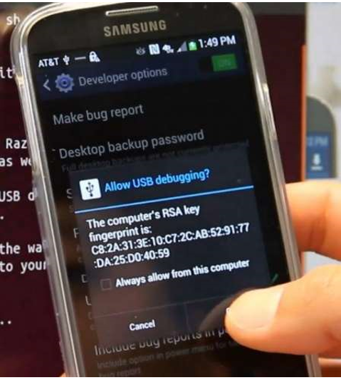

When the terminal is detected in the NFM software, as shown in the picture below, click **Check firmware** button.

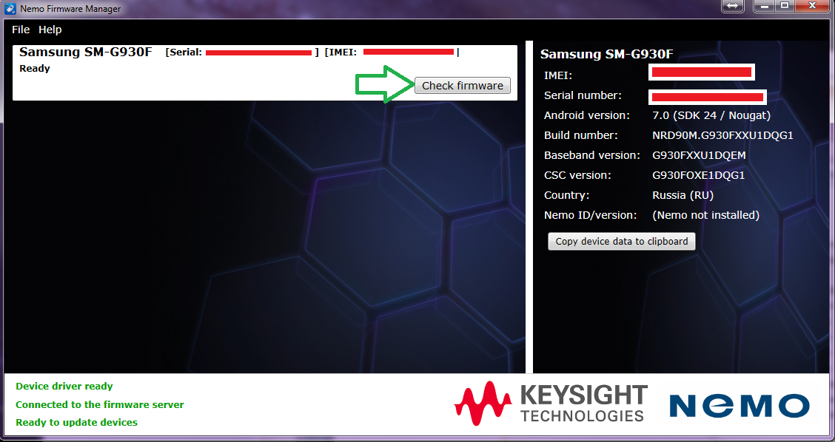

As soon as the phone goes into reboot, disconnect the USB cable.

Set up your phone as follows:

Language: English (United States) Click Start

Click Next >

*Check* Agree to all *and uncheck* Diagnostic data and Marketing information. *Click* Next >

*Uncheck* Help improve your Android experience. *Click* Next >

*Click* Next >

*Click* Next >

Protect your phone – *Check*: No, thank you *Click* Skip > *Click* Skip anyway

*Click* Skip > *Click* Skip

*Check* No, thank you *Click* Skip >

*Uncheck* Agree to all. *Click* Next >

Finish >

When the terminal is booted, set the following settings:

- Apps->Settings->Lock screen and Security:  
o Check Unknown sources (and press OK)  
- Apps->Settings->Software update:  
o Uncheck Download updates automatically

- Apps->Settings->Battery->Menu (three dots)->Advanced settings

o Uncheck App power monitor

o Uncheck Fast cable charging  
- Apps->Settings->About device->Software info:  
o Tap/press Build number around 7 times until you get a little message  
saying Developer mode has been turned on.  
- Apps->Settings->Developer options:  
o check “USB debugging” (and press OK).

o check “OEM unlock” (and press OK).

**2 Step**

Install the necessary applications.

Nemo Browser (nemobrowser-53.0.1.android-arm.apk)

SeeGullConnect (If a PCteL IBFlex scanner is connected to the terminal)

Nemo Handy

Nemo Media Router

For any questions please contact DMTel support:

+7 (495) 748 46 58

[support@dmtel.ru](mailto:support@dmtel.ru)